METASPLOITABLE 2

A test environment provides a secure place to perform penetration testing and security research. For your test environment, you need a Metasploit instance that can access a vulnerable target. The following sections describe the requirements and instructions for setting up a vulnerable target.

Open ports

PORT | STATE | SERVICE
21/tcp | Open | ftp
22/tcp | Open | ssh
23/tcp | Open | telnet
25/tcp | Open | smpt
53/tcp | Open | domain
80/tcp | Open | http
111/tcp | Open | rpcbind
139/tcp | Open | netbios-ssn
445/tcp | Open | microsoft-ds
512/tcp | Open | exec
513/tcp | Open | login
514/tcp | Open | shell
1099/tcp | Open | rmiregistry
1524/tcp | Open | ingreslock
2049/tcp | Open | nfs
2121/tcp | Open | ccproxy-ftp
3306/tcp | Open | mysql
3632/tcp | Open | distccd
5432/tcp | Open | PostgreSQL
5900/tcp | Open | vnc
6000/tcp | Open | X11
6667/tcp | Open | irc
6697/tcp | Open | unknown
8009/tcp | Open | ajp13
8180/tcp | Open | unknown
8787/tcp | Open | unknown
39292/tcp | Open | unknown
43729/tcp | Open | unknown
44813/tcp | Open | unknown
55852/tcp | Open | unknown

POC’S

For FTP port 21

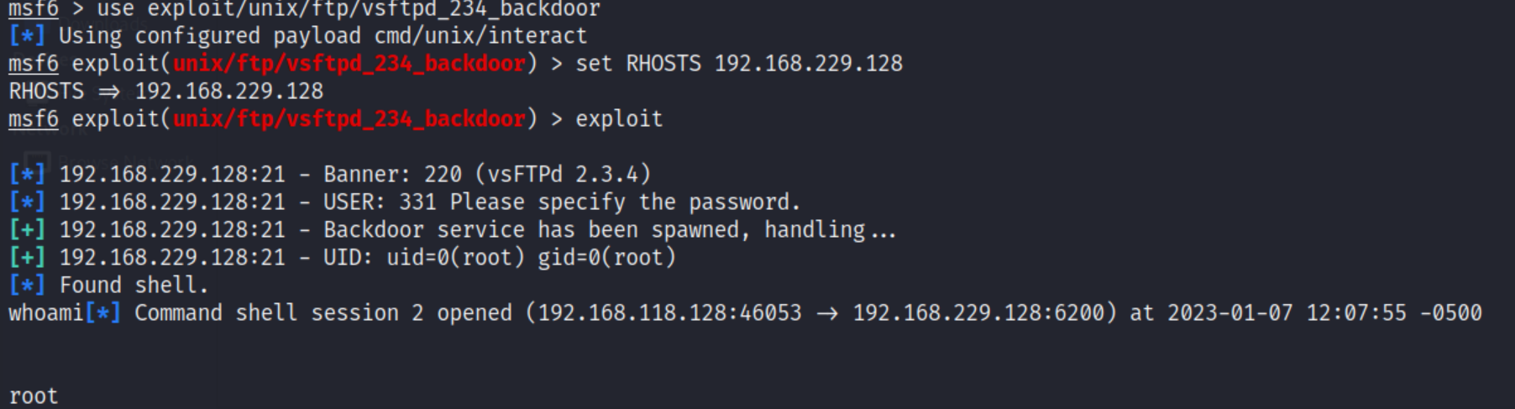

For shh port 22

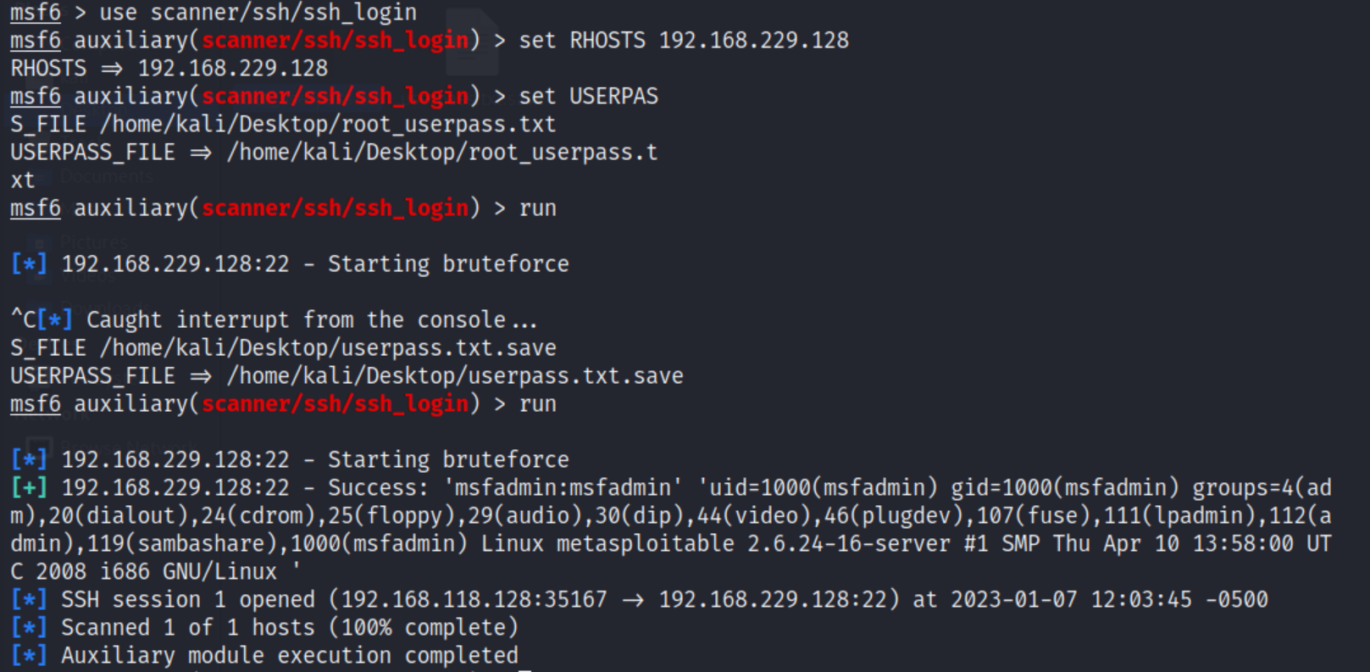

For telnet port 23

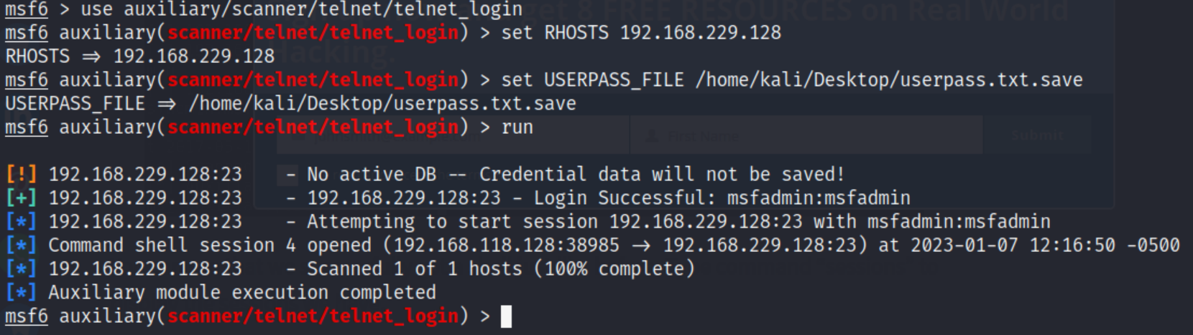

For smpt port 25

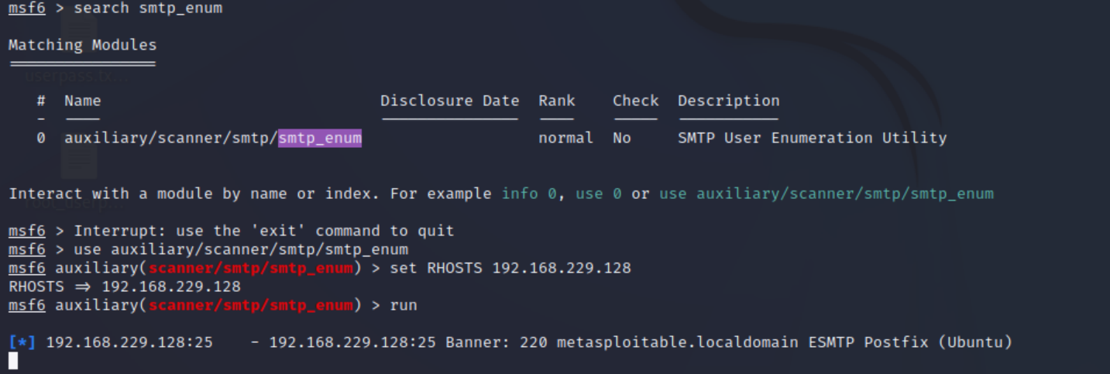

For http port 80

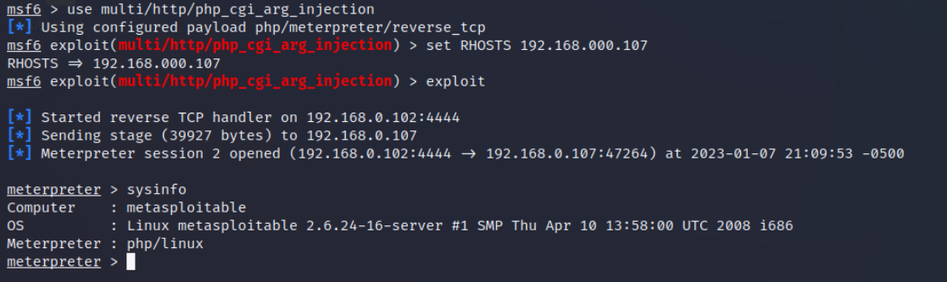

For netbios-ssn

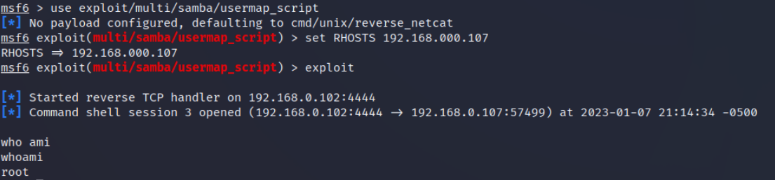

For rmi registry

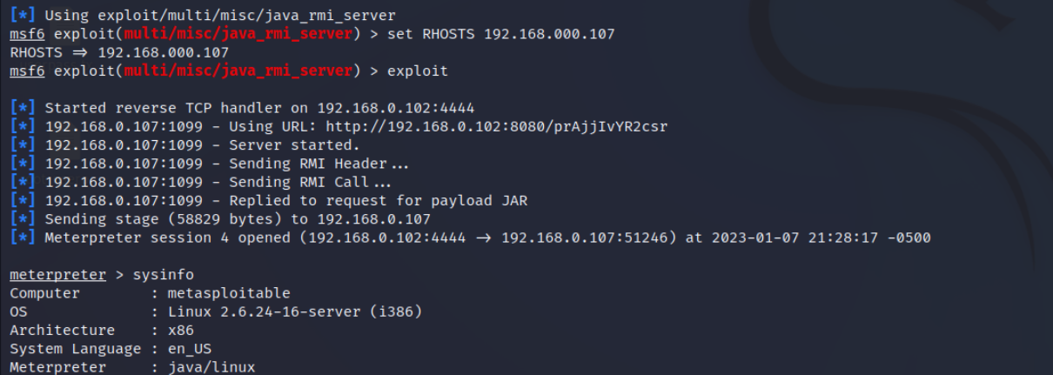

For mysql port

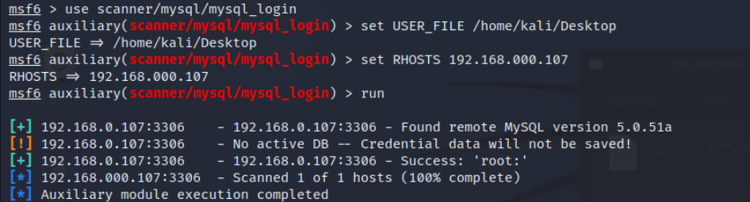

For postgresql

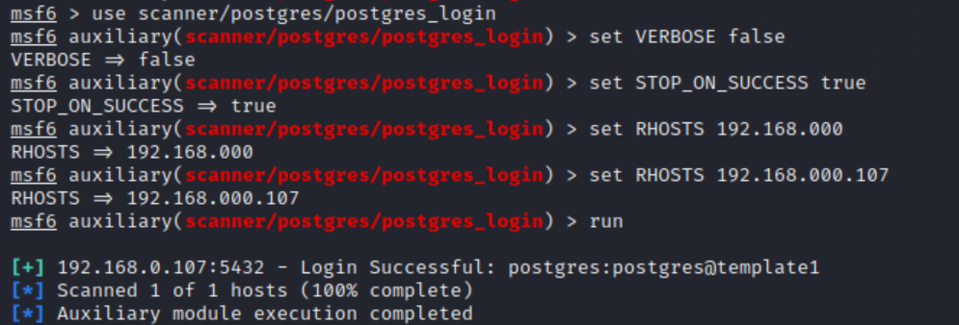

For vnc port

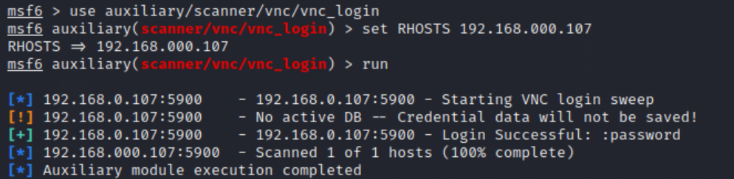

For unknown port 8081

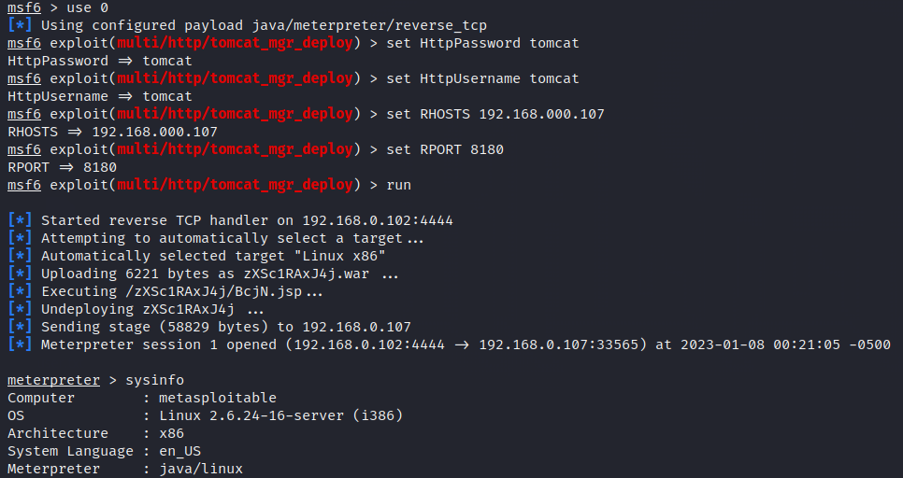

For irc port

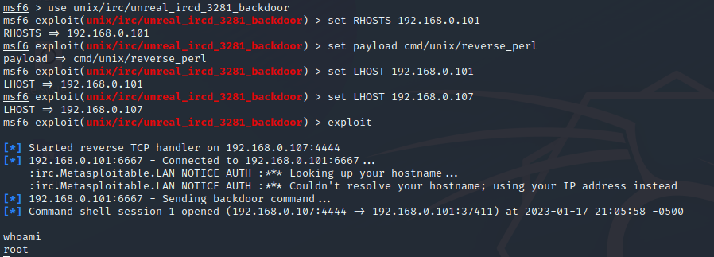

For ingreslock port

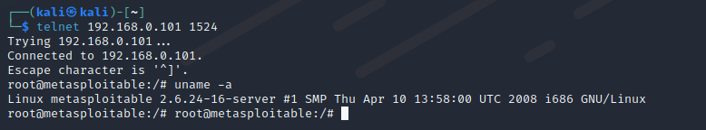

For microsoft-ds

